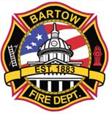
City of Bartow
Fire Department

INSPECTION REPORT

Name of Business: Bartow Achievement Academy Inspection Date: 4/22/2025

Business Address: 695 E. Summerlin St. Contact: Deborah Sulsona
Inspection Type: Annual

Result: Passed, Satisfactory and Approved

Inspector: Byron Moore
Deputy Fire Chief /
Fire Marshal
City of Bartow

State Inspector Number: 90026

Violations requiring corrective actions are listed below

Location Description Comments

No noted violations during Inspection

Comments
Yearly Inspection approved, Fire drills are complian.t

